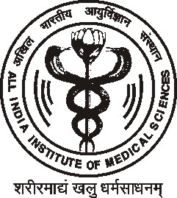
International Symposium on
“Cross-talks/Conversations on Human Reproduction, Fertility and Sexuality: Evaluation and Science, Philosophy, Art, Myths and Literature”

February 12-14, 2011
AIIMS
New Delhi

PATRONS
Prof R C Deka, Director, AIIMS
Prof NK Ganguly, Ex DG, ICMR
Dr Kapila Vatsyayan, MP Rajya Sabha

ORGANISERS
Prof Anand Kumar, MD (Chair)
Head, Department of Reproductive
Biology and Central RIA Facility
AIIMS, New Delhi, India
anandkumarrepbiol@hotmail.com

Dr S N Das, PhD
Additional Professor
Department of Biotechnology
AIIMS, New Delhi, India

ORGANIZING SECRETARIES
Dr P K Chaturvedi, PhD
Associate Professor
Department of Reproductive
Biology, AIIMS, New Delhi, India
pkchat@gmail.com

Dr A Halder, MD, DM
Associate Professor
Department of Reproductive
Biology, AIIMS, New Delhi, India
ashutoshhalder@gmail.com

Secretariat :Department of Reproductive Biology, Room No 2083, All India Institute of Medical Sciences, Ansari Nagar, New Delhi, 110029, India
Tel: 91-11-26593304, 91-11-26593234, Fax: 91-11-26588663, Email: pkchat@gmail.com

International Symposium on
“Cross-talks/Conversations on Human Reproduction, Fertility and Sexuality: Evaluation and Science, Philosophy, Art, Myths and Literature”
AIIMS
New Delhi

Date: February 12-14, 2011

Venue: AIIMS, New Delhi

Registration Fee: Delegate Rs 10000 Student Rs 3000

Secretariat :Department of Reproductive Biology, Room No 2083, All India Institute of Medical Sciences, Ansari Nagar, New Delhi, 110029, India
Tel: 91-11-26593304, 91-11-26593234, Fax: 91-11-26588663, Email: pkchat@gmail.com

